**Prerequisites**

* A MacOS
* Access to command line/terminal window

**How to Install Git on Mac**

There are many different ways to set up Git on Mac. If you prefer using a GUI, Git offers a simple installation using the installer for Mac. On the other hand, you can install Git using the terminal with a couple of simple commands.

**Option 1: Install Git on Mac with Installer**

The easiest way to set up Git is to use the Git installer for Mac.

1. Open a browser and navigate to [Git’s official website](https://git-scm.com/).

2. You will see a display showing the version number of the latest source release and a download button, as in the image below.



3. Click **Download**, and it automatically downloads the software package on your system.

4. Find the package and double-click to open the **Git installer**.

5. Follow the **installation wizard**and configure Git to suit your development needs. If you are new to version control systems, the best option would be to leave the default settings.

6. Click **Install** and type in your password if necessary.

7. Confirm once again by clicking **Install Software**.

With this, you have finished setting up Git on your Mac. Move on to the next step of [configuring Git](https://phoenixnap.com/kb/install-git-on-mac#htoc-configure-git).

**Option 2: Install Git on Mac using the Terminal**

There are multiple ways to install Git on Mac via terminal, depending on the development environment or package manager you have on your system.

This guide includes three different options.

**Install Git Using Xcode**

If you prefer the terminal, using **Xcode** is the fastest and easiest way to start working with Git. Its command-line tools include Git in the package.

Users who don’t have Xcode can install it with a single command:

xcode-select --install

With Xcode running on your Mac, you can check whether Git is also available by prompting for the **Git version**:

git --version

The output should display the latest Git release, as in the example below.



If you do not have Git, it automatically asks you whether you want to install it. Confirm the installation, and Xcode sets up Git.

**Install Git Using Homebrew**

Another way to install Git is with **Homebrew**, the package management system for Mac.

Run the following **brew** command in the terminal:

brew install git

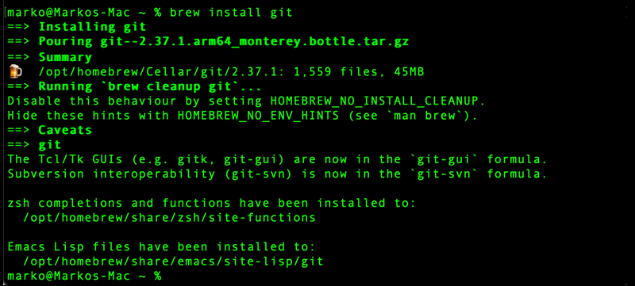

Then, **check the Git version** to verify the installation:

git --version



## Get Started with Git on Mac

### Configure Git

The next step is to configure Git by adding your credentials to the system. This is important as it helps keep track of which user is committing changes to a project.

Open the terminal and **configure your GitHub username**:

git config --global user.name "your_github_username"

Then, **add your email**:

git config --global user.email "your_email@github.com"